FINAL

January 23 2023

Women still only make up 15.1% of partners in financial services industry

- Disparity in gender representation in private equity and hedge funds raises issues including the prospect of discrimination and equal pay claims
- Imperative for firms to attract and retain female leadership

Women make up just 15.1% of partners in financial services partnerships in the UK, including private equity and hedge funds - virtually unchanged from 14.8% the previous year, says Fox & Partners, the employment and partnership law specialists.

Whilst the proportion of female partners at private equity, hedge fund and other financial service partnerships, has increased in recent years, this has been at a notably slow rate.

Catriona Watt, Partner at Fox & Partners says if gender parity amongst senior jobs in financial services is to be a realistic prospect, firms must take bolder actions to create a working culture in which women are supported and can thrive. It is not enough to appoint more women at partner level as firms will likely struggle with retention if the culture isn’t right.

Catriona Watt says private equity funds have come under pressure in recent years to narrow gender representation gaps, as institutional investors have a greater interest in the diversity and inclusion of those firms that manage their funds. Investment firms with poorer credentials may start to struggle to attract investments from those institutional investors who now look at gender diversity, amongst other aspects, as an important part in the process of picking a fund management firm

Unlike stock market listed financial services businesses such as banks, hedge funds and PE funds have not historically been subject to the same levels of external scrutiny when it comes to boardroom diversity. It may partly be as a result of this, that progress within these firms in improving gender diversity at senior management level has been slow.

As PE funds and alternative asset classes become increasingly important to the UK’s financial services sector, having strong gender diversity credentials across all levels will become even more critical.

Catriona Watt, Partner at Fox & Partners says: “Narrowing the gender representation gap at senior levels within financial services is slow going. At the current rate gender equality is unlikely tohappen for decades.”

“Poor diversity at the boardroom level can be a vicious cycle. Women may be less motivated to join a new firm if it doesn’t already have senior female leaders in place. This highlights the importance of cultivating and supporting existing female employees so that they can become the next generation of leaders and also put in place measures to attract women to the sector in the first place.”

Catriona Watt says disparities in gender representation could potentially lead to questions about sex discrimination and equal pay. Having disproportionately fewer females in senior positions could be indicative of systematic issues and firms would do well to examine and address the likely reasons for this. .

If firms want to improve gender diversity at senior levels, they should focus on creating inclusive workplaces which attract women in the first place and where women are able to excel. Fox & Partners says action firms can take include:

- Implementing a mentoring/championing scheme that supports women in progressing either from middle management to more senior roles or on a leadership fast-track scheme
- Ensuring that diversity initiatives and messaging around these are echoed across all levels of the business, from the top down. The firm should walk the walk
- Committing to initiatives for improving gender diversity in financial services partnerships, like Level 20 or the Treasury’s Women in Finance Charter

The percentage of partners at financial services partnerships increases by just 0.3% in a year

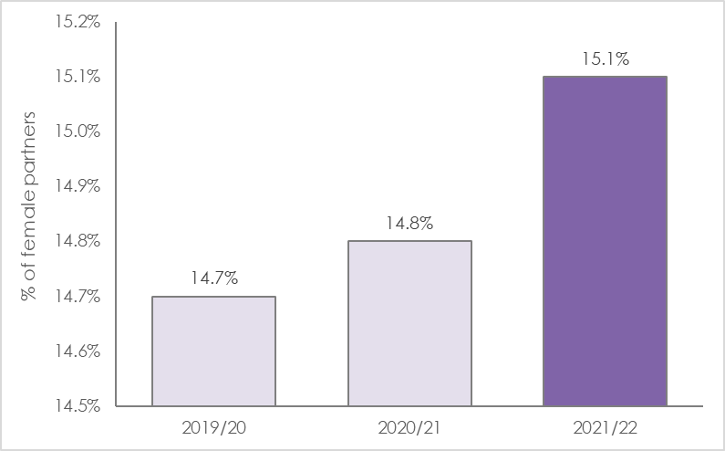

ENDS

Press Contact
Catriona Watt
Partner
Fox & Partners
D: +44 20 7618 2887
M: +44 7912 731 883

