October 23 2023
Claims of discrimination against neurodiverse employees still an issue – with over 100 Employment Tribunal cases in the last year
- One third of claims related to discrimination against dyslexic employees
Employment tribunals heard 102 cases last year in which employees said that their neurodiversity* was part of the reason for the discrimination they experienced shows new research by specialist employment law firm, Fox & Partners.
Neurodiversity is a term that describes the differing ways that people’s brains process information and includes ADHD, autism, dyslexia, and dyspraxia.

Workplace disputes can arise when neurodivergent employees feel that their performance or behaviour in the workplace is being unfairly rated for reasons that are related to their neurodiversity.

Ivor Adair, Partner at Fox says: “Whereas many employers have become more aware of neurodiversity within their workforce, that is not yet translating into strategies that are working, as disputes of this type are still making their way to Employment Tribunals.”

“Employers should be allocating resources to drive forward a more sophisticated diversity and inclusion strategy, to include neurodiversity. Employers increasingly appreciate diversity of thought leads to improved decision making and helps them compete more effectively. Retention and progression of neurodiverse individuals has a part to play in good risk management.”

“Employers will need to be astute to recognise in what way neurodivergent employees are disadvantaged by the workplace set up, be ready to discuss accommodations and ensure managers are trained so not to mishandle the situation. Reasonable adjustments might include clear and specific instructions, a quiet workspace, longer core hours with break, or a mentor. Much will depend on identifying what it is about the job the employee finds challenging, whilst maintaining their trust.”

Ivor Adair adds: “It’s thought about 15 to 20% of the population is neurodiverse. Many receive a late diagnosis and may have caring responsibilities for children who are also neurodiverse. Employers can’t afford to be complacent and need to incorporate neurodiversity as part of a modern inclusion and talent management strategy. There is more at stake than reducing the risk of claims. An inclusive culture invariability translates into a more productive and well governed workplace."

*Year-end December 31st, cases that reach a decision stage at the Employment Tribunal.

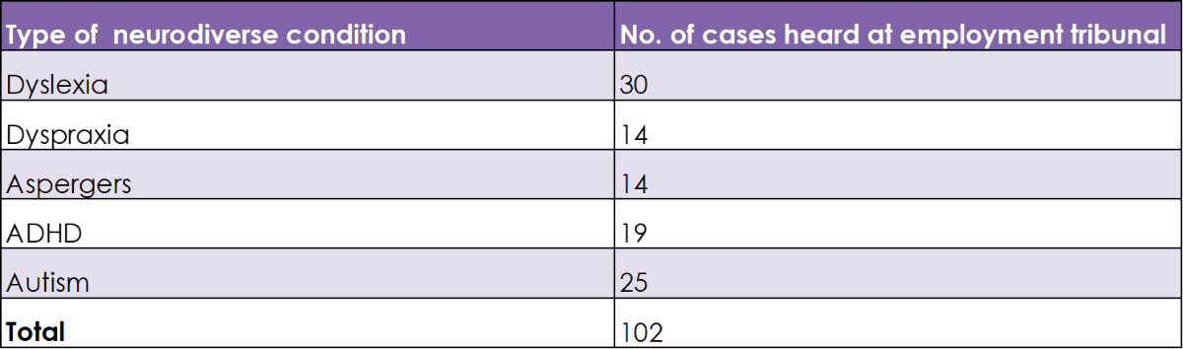

ENDS

Caroline Field
Partner
Fox & Partners
Tel: +44 20 7618 2880
Mob: +44 7714 495 077

